<http://jsfiddle.net/hvaF3/68/>

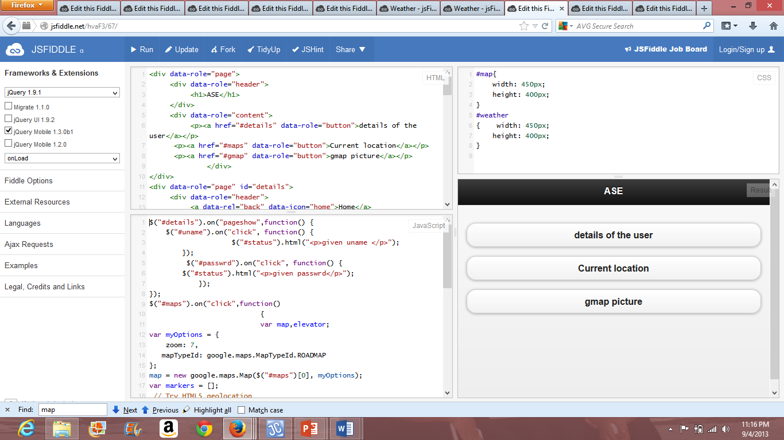

In this mobile web based application 3 services are been used. Assuming that the user is in need of the necessary location details. For this to work user’s details like his name and his password shortly called as his credentials are been displayed.

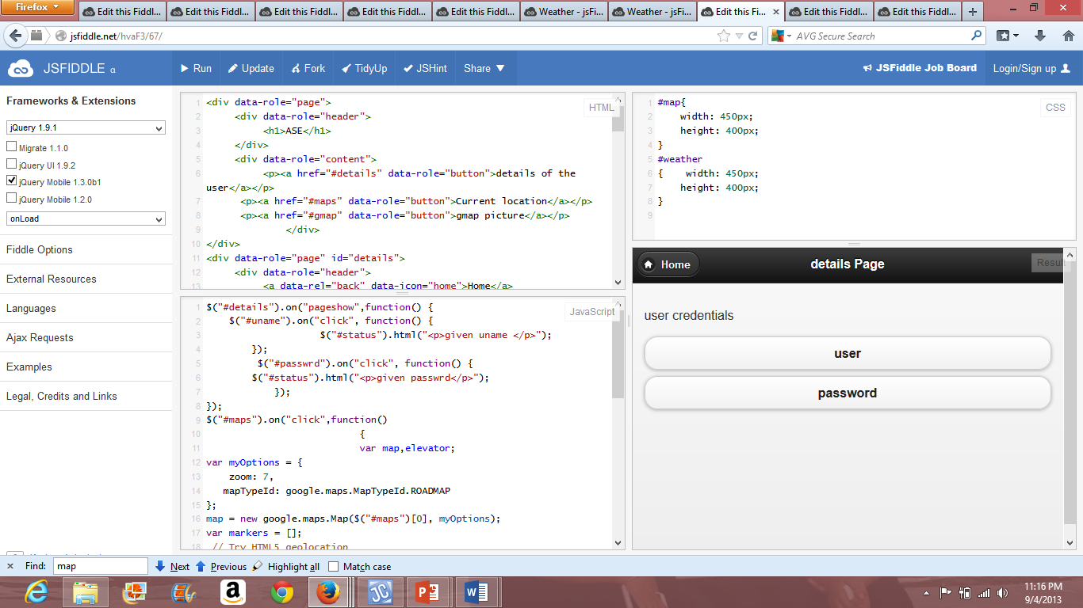

In the above screen shot the first service of the user that is the displaying the status of the clicks on the buttons i.e. when clicked on username it enlightens saying that the click is made on the username button and similarly for the password button. He can then check the things and then now opt for the further availing of the services where in he gets the previously appeared initial screen.

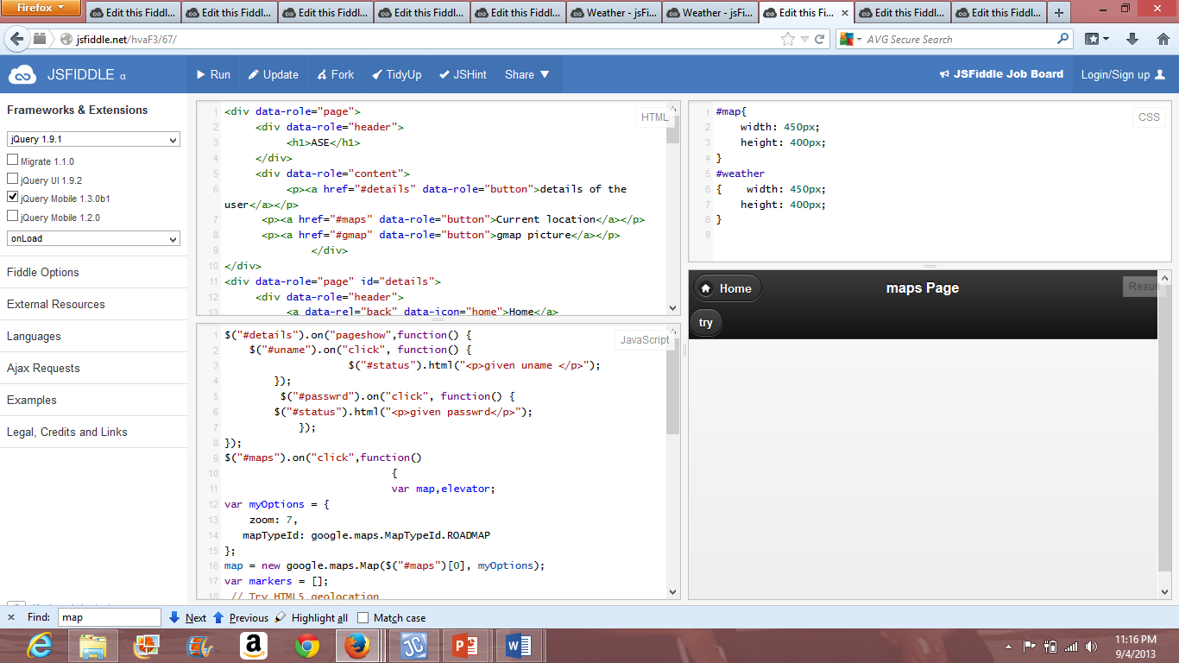

This depicts the map page that is displayed for the user to check his location. This has a heading for the convenience of the user denoting the maps page. Now on clicking the try option he can get the view of the location. Here in this app the assumed place is Kansas. He can easily view the location along with the view of the surrounding places. He can also check the necessary places of interest in the same city. He also has an option for viewing the map as he intends like zooming in and out the map as intended.

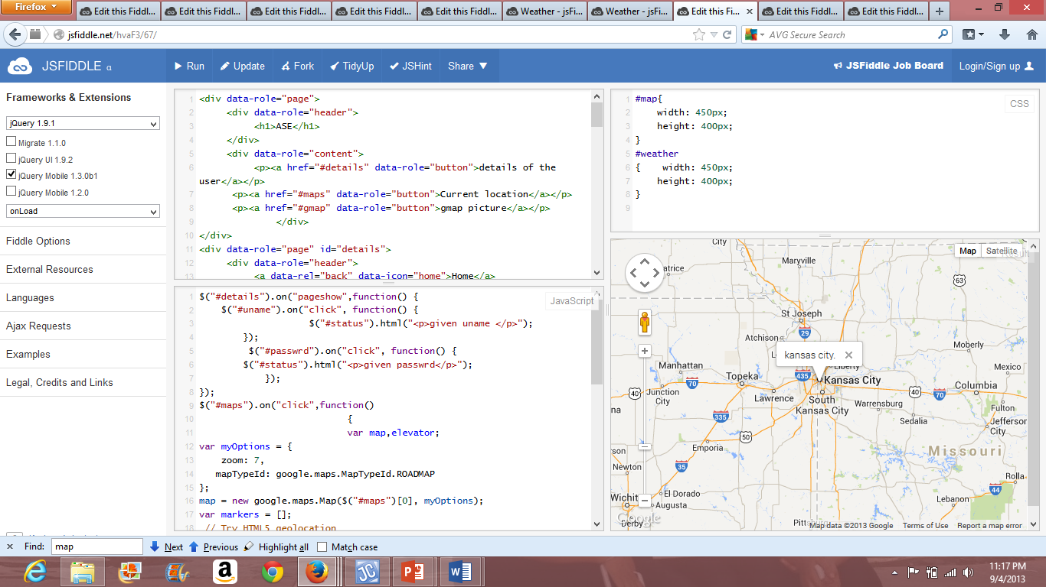

This is the final view of the location Kansas that is now displayed.

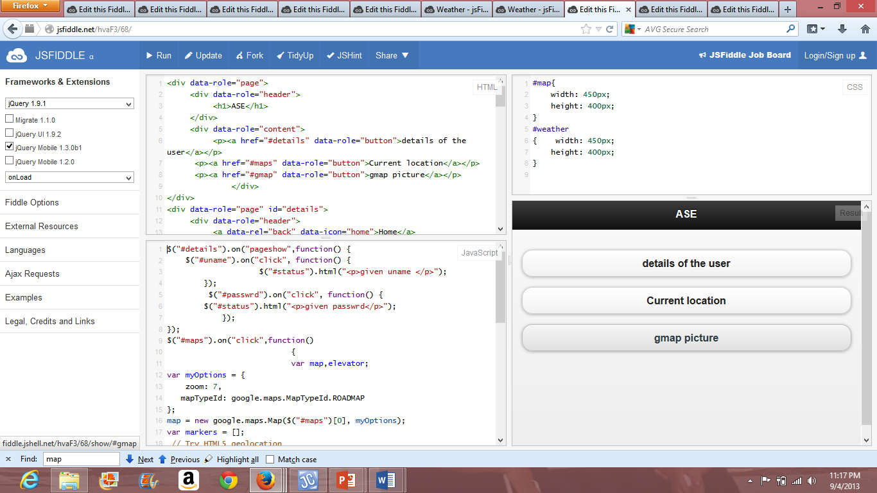

He can now opt to the initial screen for using the ultimate service that is been availed for him to use. On clicking on the gmap picture.

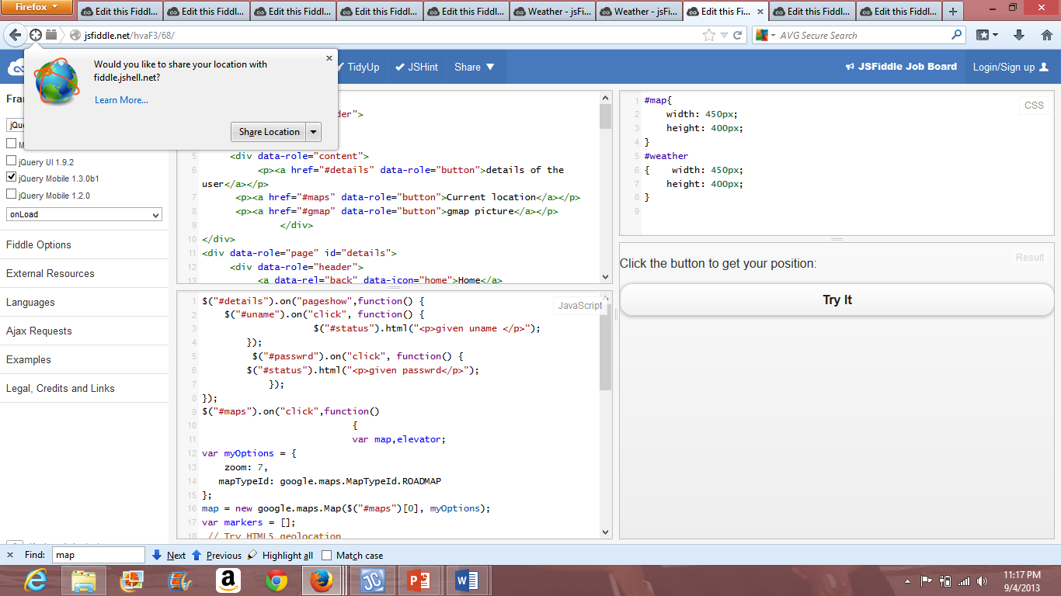

This is a view of the google picture of the location. Above is the displayed screen after clicking on the gmap button. It will then ask user whether to share his location or not. He can opt for share location. Then the following screen is been displayed.

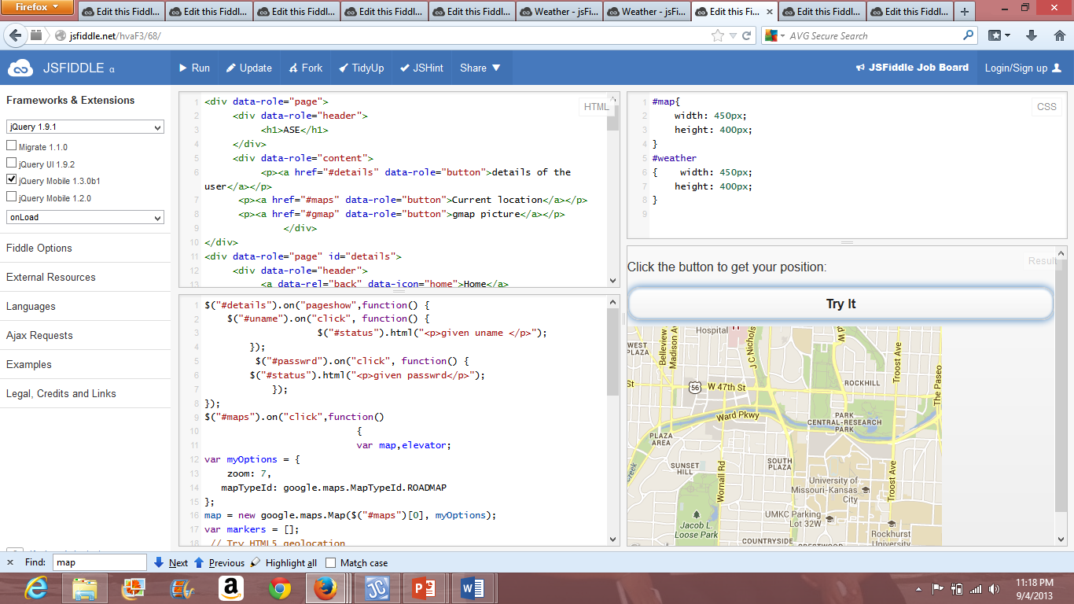

After clicking on the “try it” it displays the css given dimensions of the gmap picture of the location.

As assumed earlier the place is Kansas for this example.